

CP Assignment 02

Name: Syed Muhammad Raza Ali

Enrolment: 02-134231-028

Course: CP

Faculty: Miss Azeema Sadia

**Assignment N0. 02**

**Submission Due Date: 07-April-2023**

**Marks 05**

**Question CLO3, PLO4, BTL 3**

The university wants you to develop a system to maintain student’s registration in different sports such as cricket, football or hockey. The system allows each students to register only for single team, it means students are not allowed to register for two different games. Although a student can switch his registration from one sport to another. For instance a student A was previously registered in cricket team but now he want to register for football team, in this case his registration will be updated from cricket player to football player.

Following students are not eligible to register for sports

* Students above 25 years
* Students who are also working as teaching assistant (TA)

You system admin should be able to perform following tasks

* Register students by his/ her registration ID
* Register student to a sport
* View particular students record by using his/ her ID as each student have unique ID
* View all records each record has two values student’s ID and student’s sport name
* Update any sport of a particular student
* Delete any record at any time
* Search for specific student by his her ID and display its registered sport name

Code:

#include <iOStream>

#include <cstdlib>

using namespace std;

int main() {

char choice, option, teachingAssistant, sportsCode;

string studentName[5], sportsName[5], searchName, sportsFound, changeSport, delStudent, searchStudent;

int i = 0 ;

int studentAge,x,y,z, studentId[5];

bool flag1, flag3 = false;

do {

cout << "Press 1 to register a student " << endl

<< "Press 2 to view a specific student's record" << endl

<< "Press 3 to view all students records" << endl

<< "Press 4 to change the sport of a student" << endl

<< "Press 5 to delete the record of a student" << endl

<< "Press 6 to search for a student" << endl;

cin >> choice;

if (choice == '1') {

cout << "----------------------- Register for a sport -----------------------" << endl;

cout << "Enter your age" << endl;

cin >> studentAge;

cout << "Are you working as a Teaching assistant?" << endl

<< "Press 'y' for yes and press 'n' for no" << endl;

cin >> teachingAssistant;

if (teachingAssistant == 'n' && studentAge >= 18) {

cout << "Age requirement met :)" << endl;

cout << "Enter the name of the student" << endl;

cin >> studentName[i];

cout << "Enter the sports you want to register for" << endl

<< "Press 'c' for cricket" << endl << "Press 'f' for football" << endl

<< "Press 'h' for hockey" << endl;

cin >> sportsCode;

if (sportsCode == 'c') {

sportsName[i] = "Crickcet";

x = rand() % 100 + 1;

studentId[i] = x;

}

else if (sportsCode == 'f') {

sportsName[i] = "Football";

y = rand() % 100 + 1;;

studentId[i] = y;

}

else if (sportsCode == 'h') {

sportsName[i] = "Hockey";

z = rand() % 100 + 1;;

studentId[i] = z;

}

else {

cout << "Invalid choice!!" << endl;

}

i = i + 1;

}

else {

cout << "You are not eligible for sports registration :(" << endl;

}

}

else if (choice == '2') {

cout << "----------------------- Student's Record -----------------------" << endl;

cout << "Enter the name of the student " << endl;

cin >> searchName;

for (int j = 0; j < 5; j++) {

if (searchName == studentName[j]) {

flag1 = true;

cout << "Student Name : " << searchName << endl;

cout << "Student ID : " << studentId[j] << endl;

cout << "Sports : " << sportsName[j] << endl;

break;

}

}

if (flag1 == false) {

cout << "No record found :(" << endl;

}

}

else if (choice == '3') {

cout << "----------------------- Student's Record -----------------------" << endl;

for (int j = 0; j < 5; j++) {

cout << "Student name : " << studentName[j] <<"Student ID: "<<studentId[j]<< " Sports : " << sportsName[j] << endl;

}

}

else if (choice == '4') {

bool flag2 = false;

cout << "----------------------- Change Student's Sport -----------------------" << endl;

cout << "Enter the student name whose sport you want to change" << endl;

cin >> changeSport;

for (int j = 0; j < 5; j++) {

if (changeSport == studentName[j]) {

cout << changeSport << " found! Enter the new sport of this student " << endl

<< "Press 'c' for cricket" << endl << "Press 'f' for football" << endl

<< "Press 'h' for hockey" << endl;

cin >> sportsCode;

if (sportsCode == 'c') {

sportsName[j] = "Cricket";

}

else if (sportsCode == 'f') {

sportsName[j] = "Football";

}

else if (sportsCode == 'h') {

sportsName[j] = "Hockey";

}

else {

cout << "Invalid choice!!" << endl;

}

flag2 = true;

}

break;

}

if (flag2 == true) {

cout << "Sport updated succesfully :) " << endl;

}

else if (flag2 == false) {

cout << "Student not found :/" << endl;

}

}

else if (choice == '5') {

cout << "Enter the name of the student you want to delete" << endl;

cin >> delStudent;

for (int j = 0; j < 5; j++) {

if (studentName[j] == delStudent) {

flag3 = true;

for (int k = j; k < 5 - 1; k++) {

studentName[k] = studentName[k + 1];

studentName[k + 1] = " ";

studentId[k] = studentId[k + 1];

studentId[k + 1] = NULL;

sportsName[k] = sportsName[k + 1];

sportsName[k + 1] = " ";

}

}

}

if (flag3 == true) {

cout << "Student record deleted successfuly" << endl;

}

else {

cout << "Student doesn't exist" << endl;

}

}

else if (choice == '6') {

cout << "Enter the name of the student you want to search" << endl;

cin >> searchStudent;

for (int j = 0; j < 5; j++) {

if (searchStudent == studentName[j]) {

cout << "Student Found " << endl

<< "Name: " << studentName[j] << endl

<<"Student ID: "<<studentId[j]<<endl

<< "Sports: " << sportsName[j] << endl;

}

else {

cout << "Student doesn't exist" << endl;

}

}

}

cout << "Press 'y' if you want to continue or any other key to cancel" << endl;

cin >> option;

} while (option == 'y');

return 0;

}

Output:

Option 1: Registering students

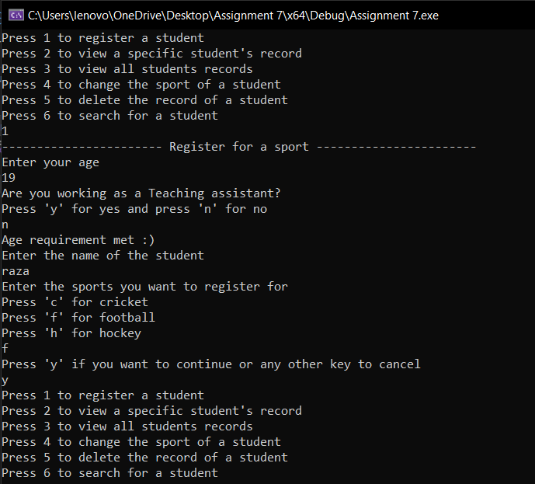

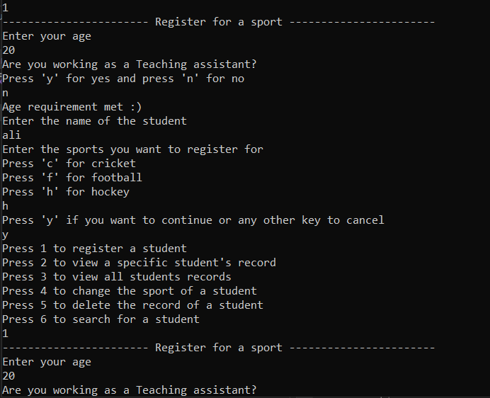

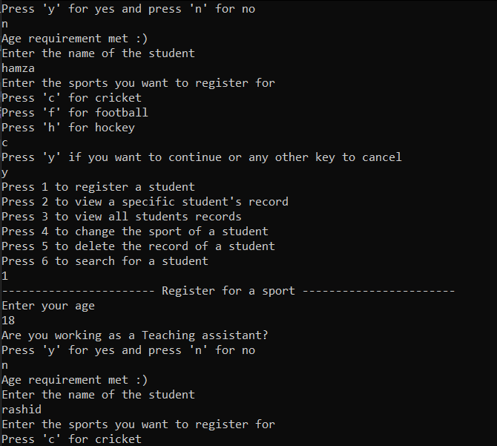

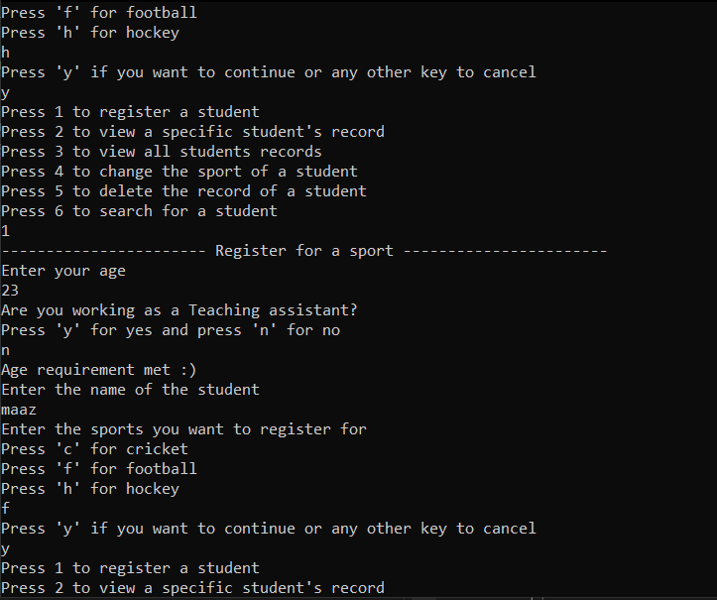

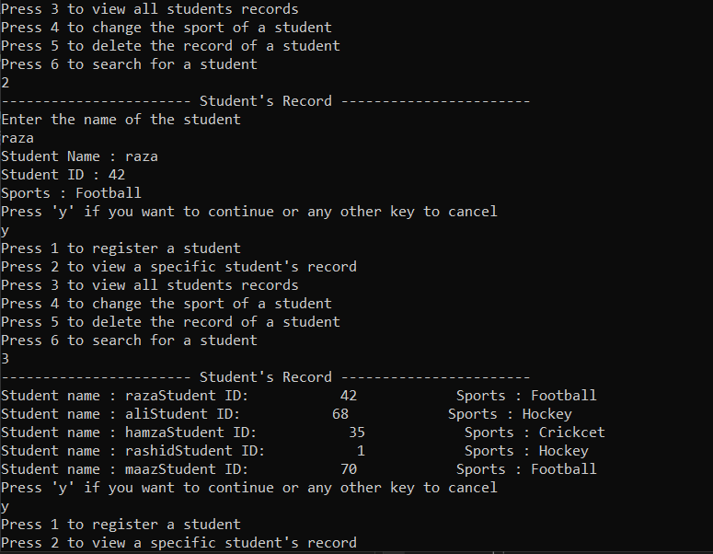Option 2 and 3: individual and all Students records

Option 4 and 5: Changing a student’s sports and deleting a student’s data

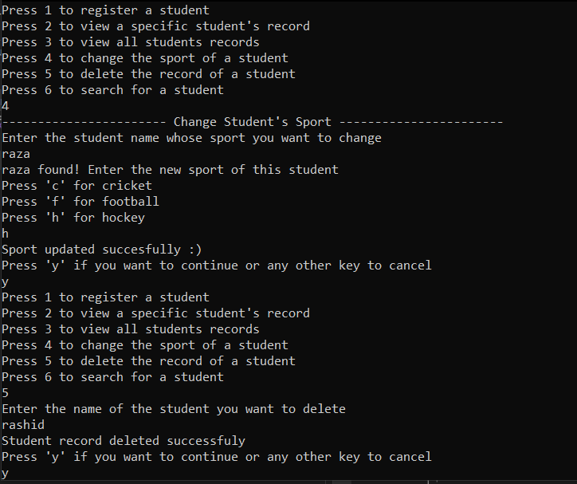

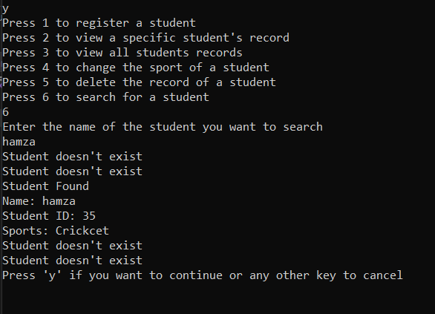Option 6: Searching a student’s data